Lab 8: Text Editors (September 21, 2026)
Compression
- Create a sample 10 MB text file by running this command:
for i in {1..440000}; do echo "Hello World Line $i"; done > sample.txt
Use gzip, bzip2, xz, and zip to compress sample.txt file, and use the command ls -lh to compare the sizes (No captured screens needed).
  - Size of gzip file = ………1.2M………….
  - Size of bzip2 file = ………483K………….
  - Size of xz file = ………159K……….
  - Size of zip file = ………1.2M……….

- TAR command
- Using tar, backup all files and subdirectories under your home directory. Place the resulting tarball file in the /tmp directory, giving it the name backup.tar.
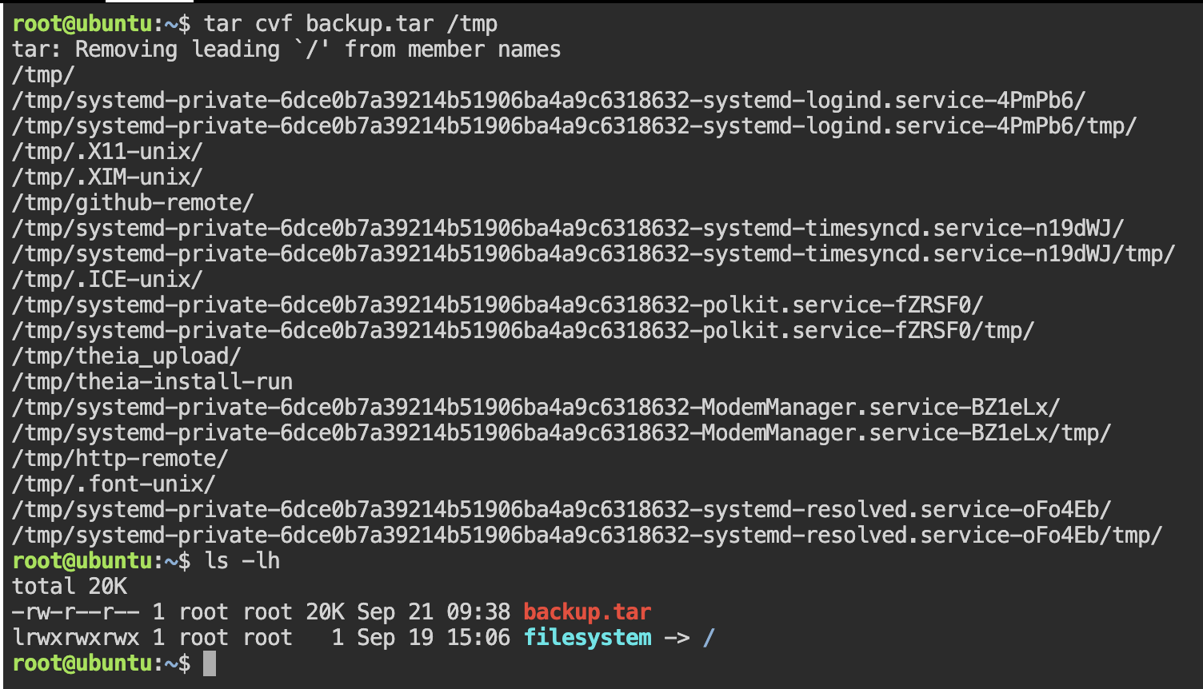
- Accomplish the same task with gzip compression using the -z option with tar, creating /tmp/backup.tar.gz.
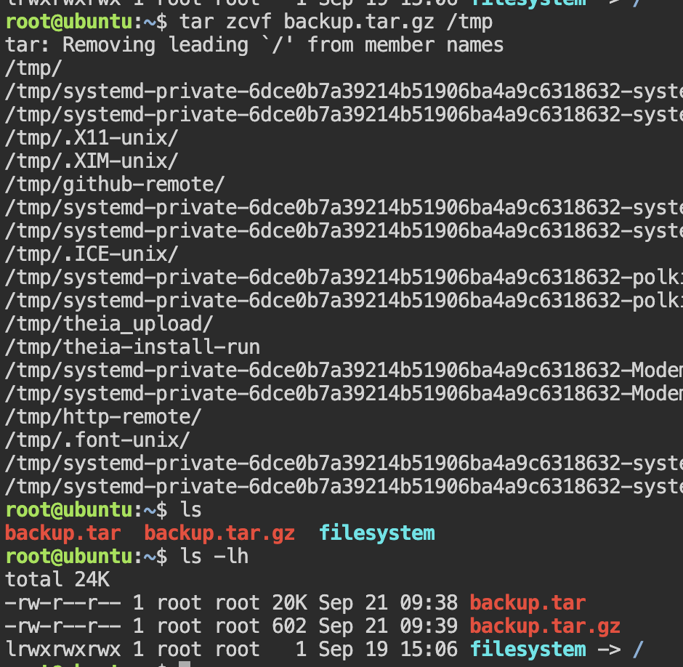
- Make backups using the -j option with bzip2 compression, and -J option with xz compression.
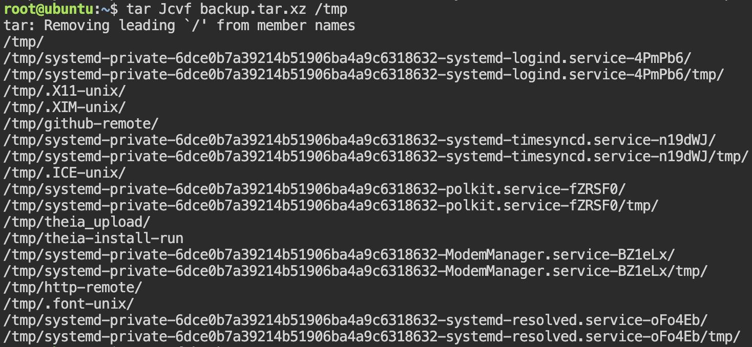
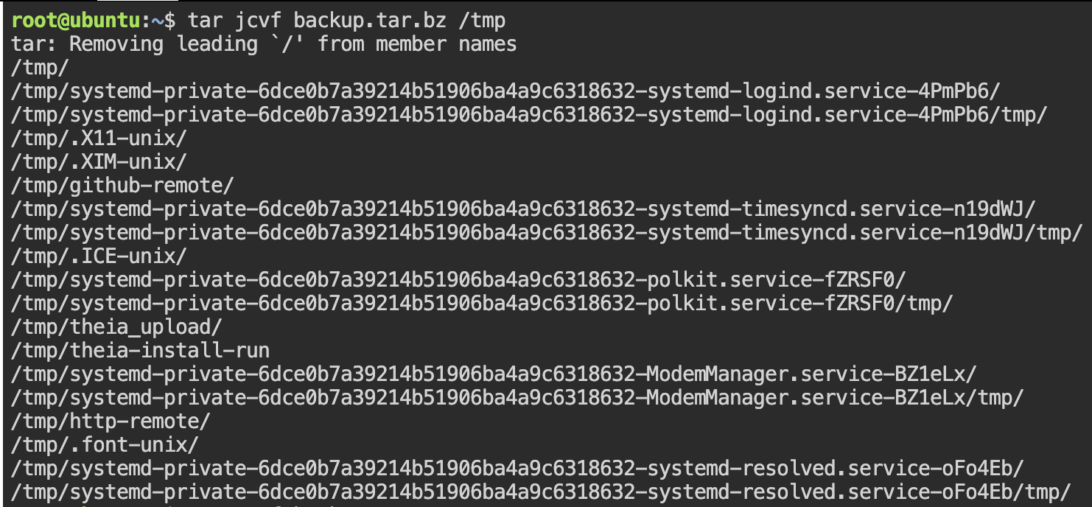
- Compare the size of all four backup files.
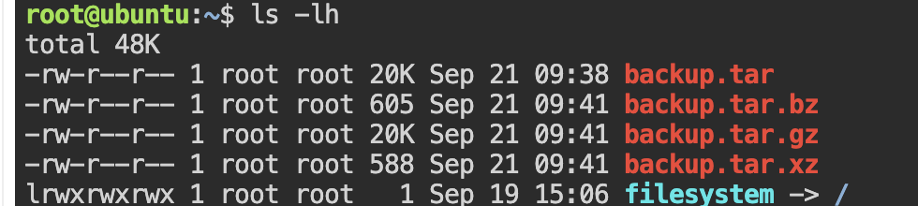

Nano
- Use nano to create a file named nano1.txt containing the following text
11111
22222
33333
44444
55555
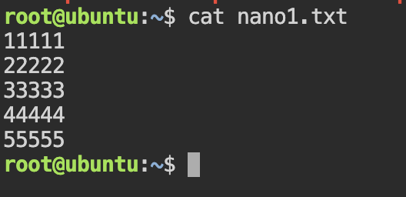
- Use cat command to create a file named nano2.txt containing the following text
aaaaa
bbbbb
ccccc
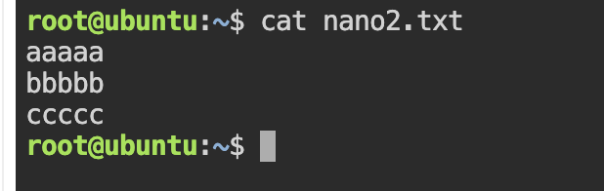
- Search “333” in nano1.txt (^w) Note: you can skip this for Windows guys!
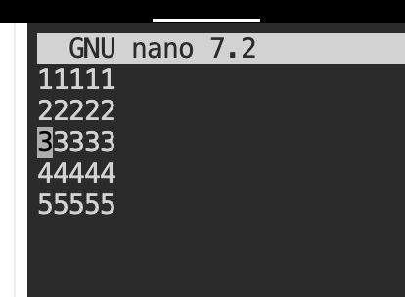
- In nano1.txt, cut last two lines and paste to the beginning of the file (^K for cut and ^U for paste)
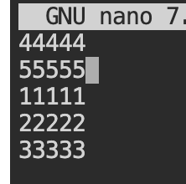
- In nano1.txt, import content of nano2.txt into the end of the file. (^R)
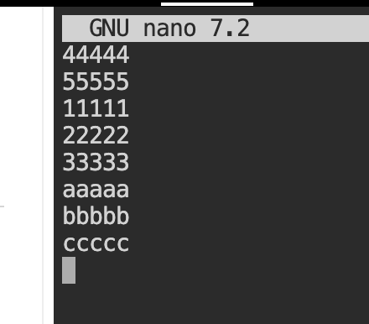

Vi Lab
- Use vi to create a file named vifile.txt containing the following text

Vim is a free and open-source, screen-based text editor program.
It is an improved clone of Bill Joy's vi. Test Text Hello Class.
Vim's author, Bram Moolenaar, derived Vim from a port of the Stevie editor for Amiga and released a version to the public in 1991.
Vim is designed for use both from a command-line interface and as a standalone application in a graphical user interface.
Since its release for the Amiga, cross-platform development has made it available on many other systems.
Test1 Test2 Test3
In 2018, it was voted the most popular editor amongst Linux Journal readers;
in 2015 the Stack Overflow developer survey found it to be the third most popular text editor, and in 2019 the fifth most popular development environment.
Vim is released under the Vim license, which includes some charityware clauses that encourage users who enjoy the software to consider donating to children in Uganda.
The Vim license is compatible with the GNU General Public License through a special clause allowing the distribution of modified copies under the GNU GPL version 2.0 or later.
Vim is highly customizable and extensible, making it an attractive tool for users who demand a large amount of control and flexibility over their text editing environment.
XXXXXXXXXX Text input is facilitated by a variety of features designed to increase keyboard efficiency.
Users can execute complex commands with "key bindings," which can be customized and extended.
Test4 Test5 Test6
Test7 Test8 Test9
The "recording" feature allows for the creation of macros to automate sequences of keystrokes and call internal or user-defined functions and mappings.
Abbreviations, similar to macros and key mappings, facilitate the expansion of short strings of text into longer ones and can also be used to correct mistakes.
Vim also features an "easy" mode for users looking for a simpler text editing solution.
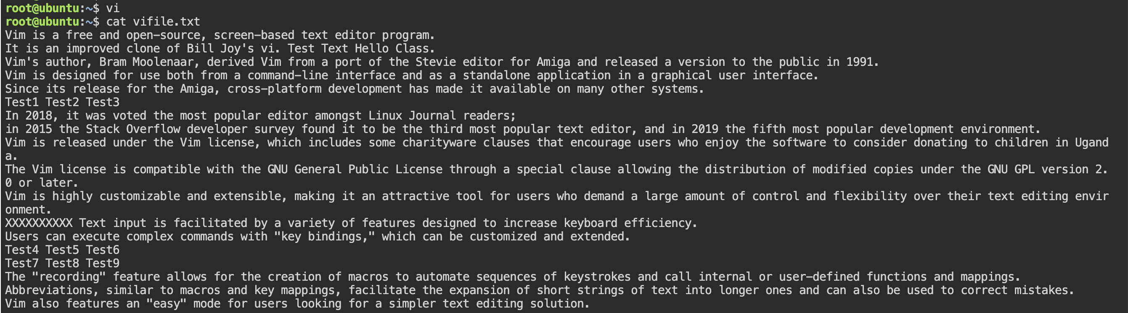
- Show line number (:set number)
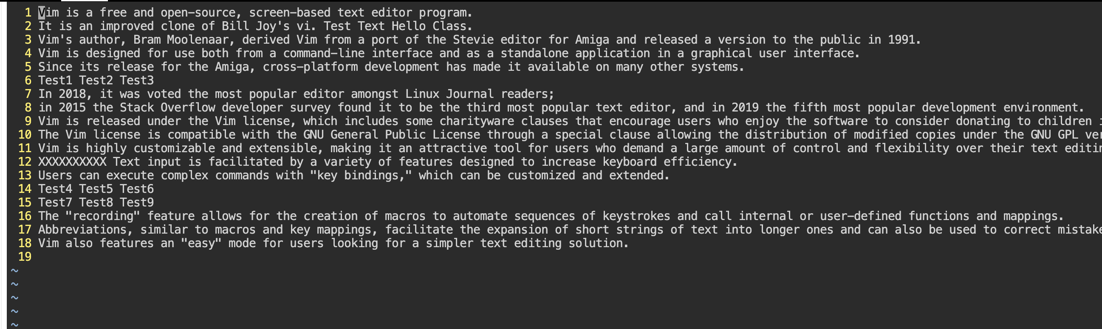
- Move cursor to
  - First line (:0)

  - Last line (:$)

  - Line 5 (:5)

  - Move to end of line 10 ($)

  - Move to the first word of line 10 (^)

  - Move to upper position of monitor (H)
  - Move to in the middle of monitor (M)
  - Move to lower position of monitor (L)
- Deletion
  - Delete the first word in the line 12 (dw)
  - Delete last two worlds in the last line by using command x
  - Delete line 6 (dd)
  - Delete line 13 to line 14 (:13,14d or move to line 13 then 2dd)
  - Go to the second line, and delete everything from word “Test” to the last word in this line (D)
- Searching
  - Search the word “Vim” for forward and backward positions.
  - Count how many “Vim” words in this file. (:%s/Vim//gn)
    - 2matches 2 on 2 lines
- Replace “is” with “was” everywhere.
- Copy lines 3 - 4 and paste at the last line.
- Undo the previous operation (u)
- Switch between line 1 and line 2.
- Capture the screen and paste it below. Save the file and exit.
